Sample of Original Research Article Preparation

NAME OF RESEARCH ARTICLE (ENGLISH) (18 pt)
Name of Research Article (Thai) (16 pt)
Name and Last name of main author, co-authors (English) (14 pt)
Name and Last name of main author, co-authors (Thai) (14 pt)
Affiliation of the main author (English) (14 pt)
Affiliation of the main author (Thai) (14 pt)
Corresponding Author E-mail:
Abstract (18 pt) (Not more than 250 words)
(16 pt) Objectives of this research were: 1. .
2. and 3. Populations and sample, research tools, Data collection, Data analysis. Statistics used for data analysis. Findings were as follows: ( present only the most interesting research findings) .
.
.
.
Keywords: 3-5 words (16 pt) such as Buddhism, Buddhist Management, Innovation

Abstract (Thai) (18 pt) (Not more than 250 words)
(16 pt) consistent with Thai abstract .
.
.
.
.
.
.
.
Keywords: (Thai)
Introduction (18 pt) (should not be more than 4 paragraphs)
(16 pt) mention background of the research topic with brief history as how the topic develops with correct references, .
.
.
.
(16 pt) mention problems leading to research directly to the point of the research and relate the matter to locations in which research is conducted on the common problems generally accepted and want them to be solved. .
.
.
.
(16 pt) Review related at least 2 concepts and theories to be used as guideline for the research and/or theories related to the research topic with correct references of data sources .
.
.
.
.
(16 pt) Conclude to connect the matters to research questions and objectives of the research .
.
.
.
.
.

Research Objectives (18 pt)
1. (16 pt) .
2. (16 pt) .
3. (16 pt) .

Methodology (18 pt)
(16 pt) Write to cover 5 sub-headlines: Research design, Populations and Samples and Key Informants, Research Instrument (quantitative and qualitative), Data Collection, (quantitative and qualitative) Data analysis (quantitative and qualitative), Statistics used to analyzed the data. .
.
.
.
.
.
.

Results (18 pt) (Present to cover all set objectives)
(16 pt) results of the research answer all objectives .
.
.
.
.
.
.
.
.
.
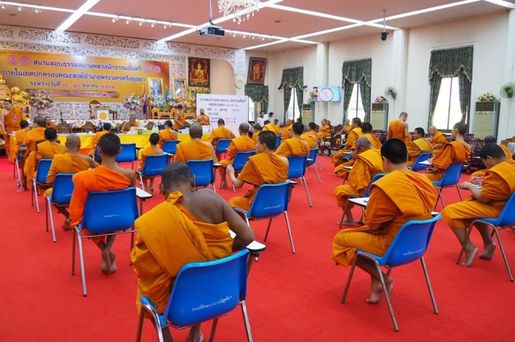
Figure 1: (Name of the figure, if any))
Source: mention the name of the source
Figure captions .
.
.
.
.

Table 1 (Name of table, if any)
Table explanation .
.
.
.
Discussion (18 pt)
(16 pt) Discuss the research findings according to the research objectives
(what is discovered? what is reflected? Is it related to at least two topics of the reviewed research works in chapter 2. Discuss them all with references of data sources .
.
.
.
.
.
.

Body of knowledge (18 pt)
(16 pt) Point out the body of knowledge or achievement from the research work. Synthesize the knowledge in form of a model/ Model structure that is concise and easy to understand .
.
.
.
.

Recommendations (18 pt)
(16 pt) Summarize all research findings in brief, concise and to the point with recommendations derived from the research work as to use the research results and recommendation for further research .
.
.
.
References (18 pt)
(16 pt) Format of reference is name-year as of American Psychological Associate (APA) References in contents and at the end must be consistent. .
.
.
.
.
.
.
.
.
.
.
.
.
.
.
.
.
.
.
.
.
.
.
.
.
.
Sample of Original Academic Article Preparation

NAME OF ACADEMIC ARTICLE (ENGLISH) (18 pt)
Name of Academic Article (Thai) (16 pt)
Name and Last name of main author, co-authors (English) (14 pt)
Name and Last name of main author, co-authors (Thai) (14 pt)
Affiliation of the main author (English) (14 pt)
Affiliation of the main author (Thai) (14 pt)
Corresponding Author E-mail:
Abstract (18 pt) (Not more than 250 words)
(16 pt) .
.
.
.
.
.
.
.
Keywords: 3-5 words (16 pt) such as Buddhism, Buddhist Management, Innovation

Abstract (Thai) (18 pt) (Not more than 250 words)
(16 pt) consistent with Thai abstract .
.
.
.
.
.
Keywords: (Thai)
Introduction (18 pt)
(16 pt) .
.
.
.
.
.
.
.
.
.
.
.
.
.
.
.
.
.
.
.
.
.
.
.
.
.
.
Content (18 pt)
(16 pt) .
.
.
.
Figure 1: (Name of the figure, if any))
Source: mention the name of the source
Figure captions .
.
.

Table 1 (Name of table, if any)
Table explanation .
.
Conclusion (18 pt)
(16 pt) .
.
.
.
.
.
.

References (18 pt)
(16 pt) Format of reference is name-year as of American Psychological Associate (APA) References in contents and at the end must be consistent. .
.
.
.
.
.
.
.
.
.
.
.
.
.
.
.
.

